**ASSIGNEMT 1**

**Instructions:**

Hello Everyone!

Please find below the assignment sums. These are taken from book that I referred to :Introduction to the Practice of Statistics 8th Edition Moore/McCabe/Craig

1.169

1.170

1.171

1.172

1.176

You can use manual calculations, R, or MS excel whichever is convenient for you to answer the above questions.

**1.169 How much vitamin C do you need?**

The Food and Nutrition Board of the Institute of Medicine working in cooperation with scientists

from Canada have used scientific data to answer this question for a variety of vitamins and

minerals.47 Their methodology assumes that needs, or requirements, follow a distribution. They

have produced guidelines called dietary reference intakes for different gender-by-age combinations. For vitamin C, there are three dietary reference intakes: the estimated average requirement (EAR),which is the mean of the requirement distribution; the recommended dietary allowance (RDA),which is the intake that would be sufficient for 97% to 98% of the population; and the tolerable upper level (UL), the intake that is unlikely to pose health risks. For women aged 19 to 30 years, the EAR is 60 milligrams per day (mg/d), the RDA is 75 mg/d, and the UL is 2000 mg/d.

(a) The researchers assumed that the distribution of requirements for vitamin C is Normal. The EAR gives the mean. From the definition of the RDA, let’s assume that its value is the 97.72 percentile. Use this information to determine the standard deviation of the requirement distribution.

(b) Sketch the distribution of vitamin C requirements for 19- to 30-year-old women. Mark the EAR, the RDA, and the UL on your plot.

**1.170 How much vitamin C do men need?**

Refer to the previous exercise. For men aged 19 to 30 years, the EAR is 75 milligrams per day

(mg/d), the RDA is 90 mg/d, and the UL is 2000 mg/d. Answer the questions in the previous exercise for this population.

**1.171 How much vitamin C do women consume?**

To evaluate whether or not the intake of a vitamin or mineral is adequate, comparisons are made between the intake distribution and the requirement distribution. Here is some information about the distribution of vitamin C intake, in milligrams per day, for women aged 19 to 30 years:

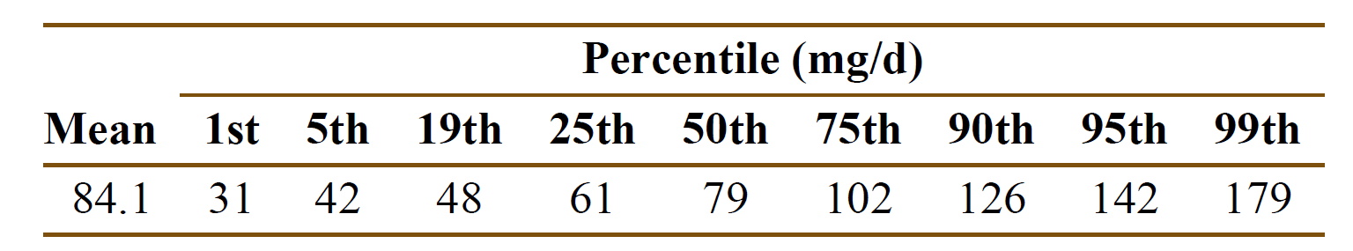

(a) Use the 5th, the 50th, and the 95th percentiles of this distribution to estimate the mean and

standard deviation of this distribution assuming that the distribution is Normal. Explain your method

for doing this.

(b) Sketch your Normal intake distribution on the same graph with a sketch of the requirement

distribution that you produced in part (b) of Exercise 1.69.

(c) Do you think that many women aged 19 to 30 years are getting the amount of vitamin C that they need? Explain your answer.

**1.172 How much vitamin C do men consume?**

To evaluate whether or not the intake of a vitamin or mineral is adequate, comparisons are made

between the intake distribution and the requirement distribution. Here is some information about the distribution of vitamin C intake, in milligrams per day, for men aged 19 to 30 years:

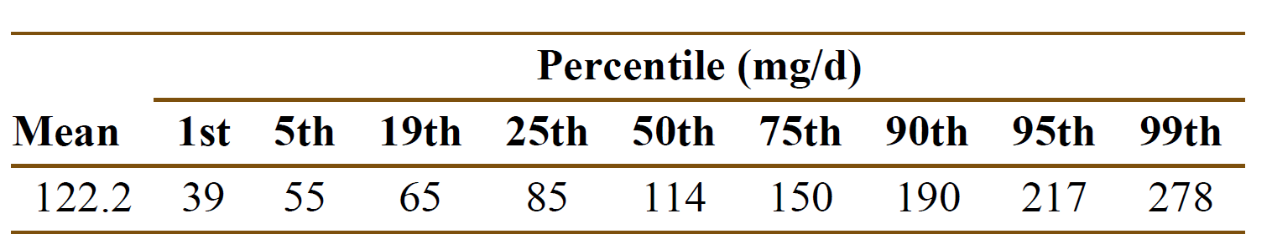

(a) Use the 5th, the 50th, and the 95th percentiles of this distribution to estimate the mean and

standard deviation of this distribution assuming that the distribution is Normal. Explain your method for doing this.

(b) Sketch your Normal intake distribution on the same graph with a sketch of the requirement

distribution that you produced in Exercise 1.70.

(c) Do you think that many men aged 19 to 30 years are getting the amount of vitamin C that they

need? Explain your answer.

**1.176 Norms for reading scores.**

Raw scores on behavioral tests are often transformed for easier comparison. A test of reading ability has mean 70 and standard deviation 10 when given to third-graders. Sixth-graders have mean score 80 and standard deviation 11 on the same test. To provide separate “norms” for each grade, we want scores in each grade to have mean 100 and standard deviation 20.

(a) What linear transformation will change third-grade scores *x* into new scores *x*new = *a* + *bx* that have the desired mean and standard deviation? (Use *b* > 0 to preserve the order of the scores.)

(b) Do the same for the sixth-grade scores.

(c) David is a third-grade student who scores 72 on the test. Find David’s transformed score. Nancy is a sixth-grade student who scores 78. What is her transformed score? Who scores higher within his or her grade?

(d) Suppose that the distribution of scores in each grade is Normal. Then both sets of transformed scores have the *N*(100, 20) distribution. What percent of third-graders have scores less than 75? What percent of sixth-graders h­­­­­­ave scores less than 75?